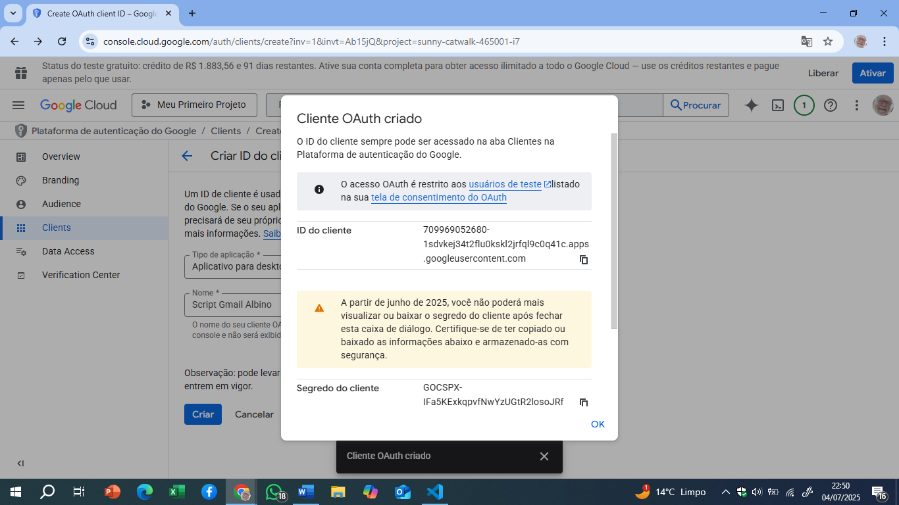

709969052680-1sdvkej34t2flu0kskl2jrfql9c0q41c.apps.googleusercontent.com
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

